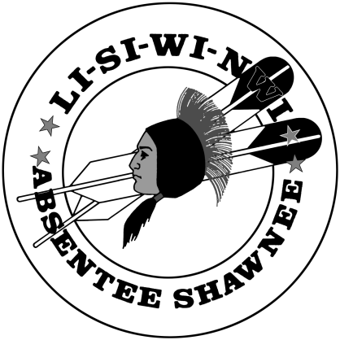
TERMS AND CONDITIONS
The Absentee Shawnee Tribe of Oklahoma will be offering salvage vehicles, miscellaneous heavy equipment, office furniture and equipment for sale at a SEALED BID PUBLIC AUCTION at Thunderbird Casino: 15700 East State Highway 9, Norman, OK on June 22, 2023 at 12:00pm.
All items will be sold AS IS with attachments, parts, accessories or quantities as shown at the time of the sale.
All items will be available to view and inspect at Thunderbird Casino at 15700 East State Highway 9, Norman, OK on June 22, 2023 between 8:00am to 11:59am. All items will be available to view on The Absentee Shawnee Tribe of Oklahoma website at www.astribe.com under Procurement on the SERVICES tab beginning Friday May 19, 2023.
By making a bid, every bidder accepts the following terms and conditions:
- Vehicles and equipment will be sold individually.
- Vehicles and equipment may contain deficiencies known to the Tribe. However, the absence of such information does not mean that deficiencies do not exist nor does it change the terms of the sale which are “AS IS, WHERE IS”, with no guarantee or warranty either expressed or implied. Buyers shall rely entirely on their own inspection and information.
- The Absentee Shawnee Tribe of Oklahoma assumes no liability for loss or injury that may occur during inspection, bidding or removal of the vehicles and heavy equipment offered for sale or for loss or damage to property following the sale.
- The successful bidder will be furnished with an original title if available and a bill of sale. It is the responsibility of the successful bidder to apply to the State of Oklahoma, Department of Motor Vehicles for a title to the vehicle.
- The successful bidder will be required to make full payment of the purchase price* at the day of the sale by credit card.
*6% tribal sales tax will be added to the winning bid unless proof of tax exemption is provided and a credit card processing fee of 2.6% + 10 cents.
- The Absentee Shawnee Tribe of Oklahoma has the right to refuse any and all bids.
- Successful bidder will be notified by announcing name at the auction, followed by two (2) back to back phone calls. Winner will have 30 minutes to report to tribal finance table to pay. If winner does not present payment at the end of 30 minutes, the tribe will contact the next highest bidder for payment.
- No item will be released until full payment is received by the Tribe. The purchaser shall, at his/her own expense, remove all awarded item(s) the day of the sale by 5:00pm. Although the Tribe will exercise reasonable efforts to safeguard items while on Tribal property, it is released from any responsibility for the care and protection during this time.
- The Absentee Shawnee Tribe of Oklahoma may resell any item, if the purchaser fails to comply with the terms of the sale. In such event, the party failing to comply will forfeit payment for item(s) and the item(s) will be offered to the next bidder.

I HEREBY AGREE TO THE TERMS AND CONDITONS RELATING TO MY PURCHASE AS STATED ABOVE.
Signature of Buyer: _________________________________________________________
Printed Name: _____________________________________________________________
Address: __________________________________________________________________
__________________________________________________________________
__________________________________________________________________
Date: _____________________________________________________________________
Telephone Number: _________________________________________________________

